Předminulý čas - Past perfect

Předminulý čas prostý

kladná věta: Had + past participle (-ed)
záporná věta: Had + not + past participle (-ed)
otázka: Had + subject + past participle (-ed) …..

- vid dokonavý, říká nám, že se něco (ne) stalo před bodem v minulosti
- to, co se stalo (minulý) bylo důsledkem toho, co se stalo předtím (předminulý)
- objevuje se ve větě s minulým časem
- často se ve větách objevuje When, Because, That, Which, Who, After, As soon as, Before,

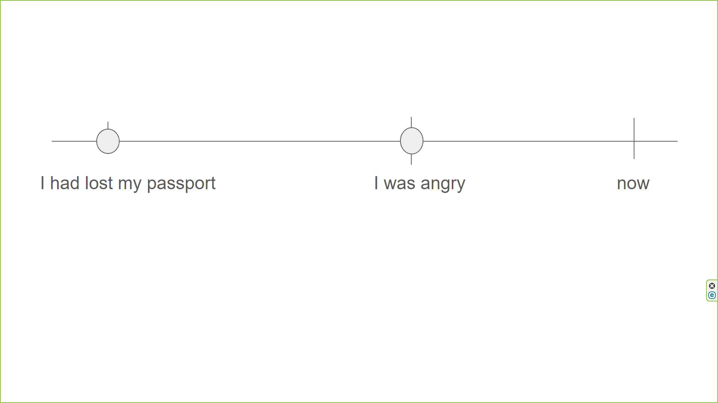

- I couldn’t buy it because I had forgotten my wallet.
- I knew that something had happened.
- I told my parents that I had passed the exam.
- She had published her first poem by the time she was eight.
- When the police arrived, the thief had escaped.

Předminulý čas průběhový
kladná věta: Had + been + -ing
záporná věta: Had + not + been + -ing
otázka: Had + subject + been + -ing …

- něco probíhalo až do bodu v minulosti
- to, co jsme viděli v bodě v minulosti (minulý) bylo důsledkem toho, co probíhalo až do té chvíle (předminulý průběh)
- klade důraz na průběh, něco se dělo
- může se objevit jak dlouho to probíhalo

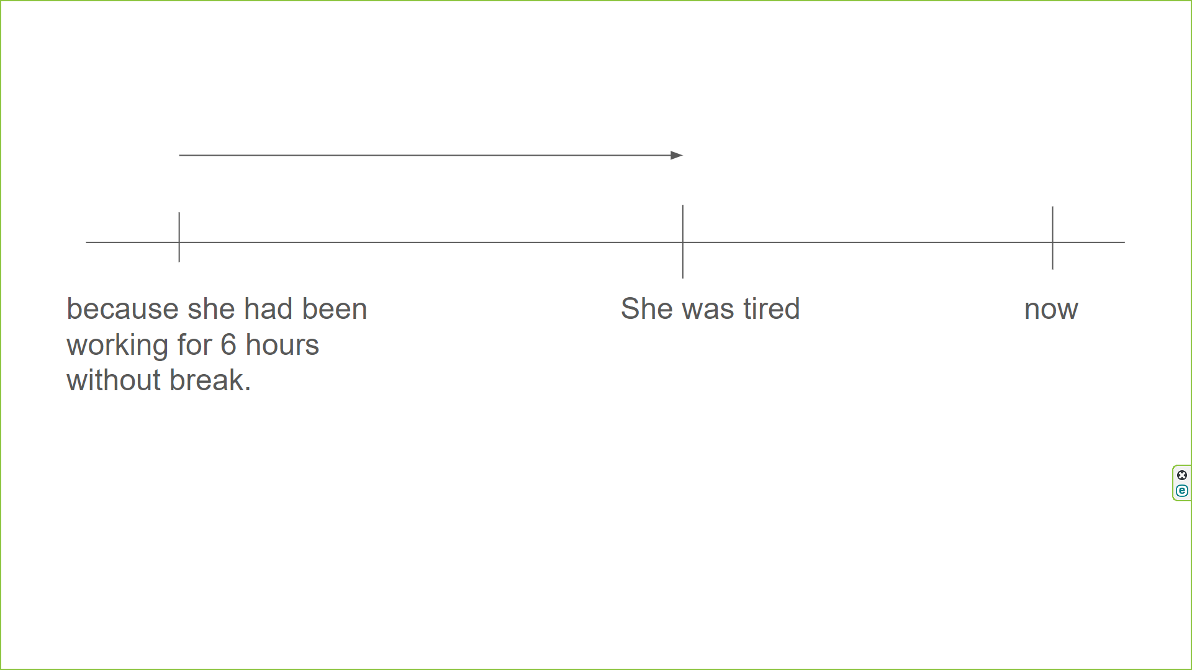

- The kids were bored, because they had been listening to the teacher for 45 minutes.
- How long had he been waiting when she finally arrived?
- She realized that he hadn’t been trying hard enough lately.
- He had dirty hands because he had been working in the garden.
- Jane had been walking three miles a day before she broke her leg.

